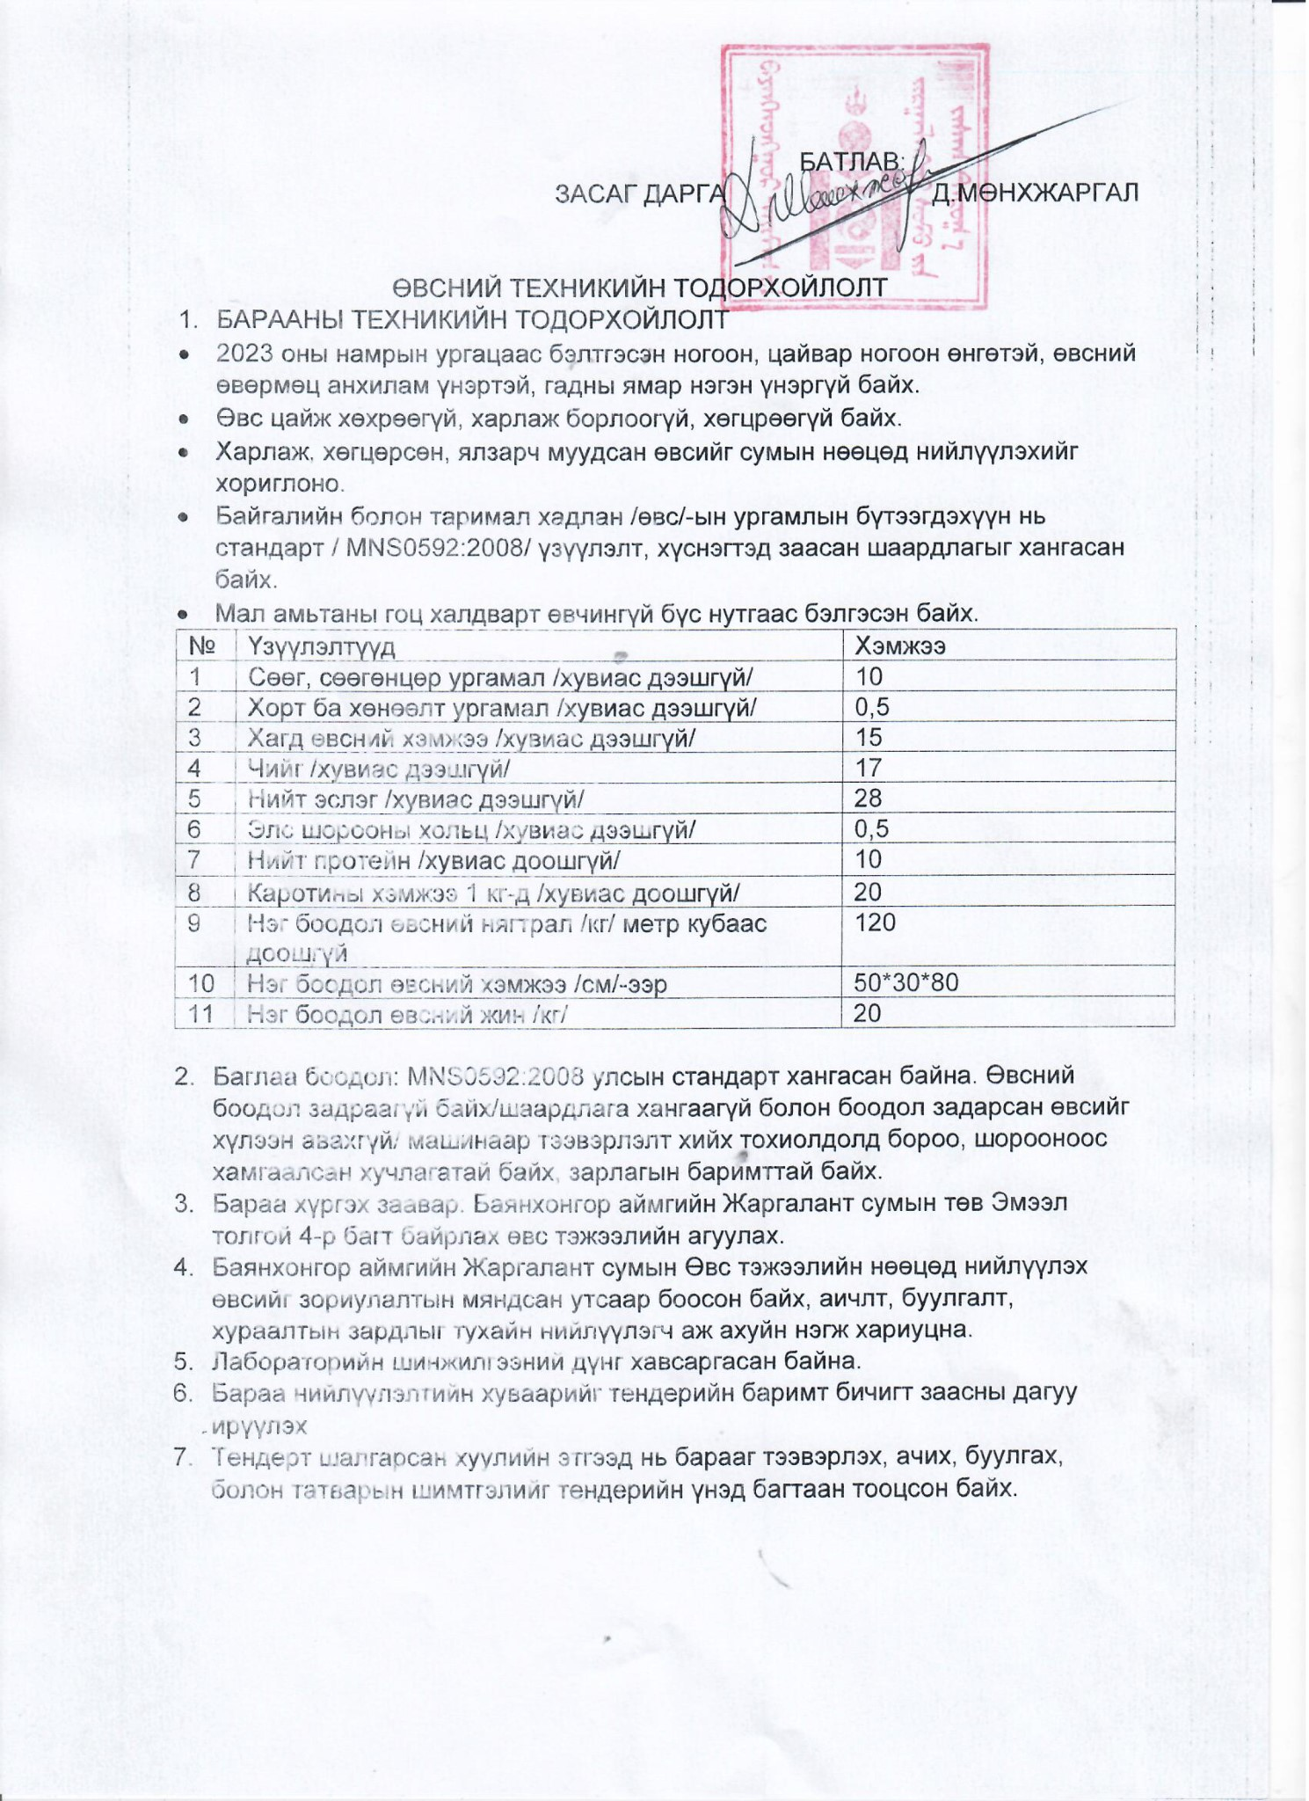

**[Click to BUY NOW](https://www.tracker-software.com/product/pdf-xchange-editor)**

[**!**](https://www.tracker-software.com/product/pdf-xchange-editor)

[**P**](https://www.tracker-software.com/product/pdf-xchange-editor)

[**D**](https://www.tracker-software.com/product/pdf-xchange-editor)

[**F**](https://www.tracker-software.com/product/pdf-xchange-editor)

[**-**](https://www.tracker-software.com/product/pdf-xchange-editor)

[**X**](https://www.tracker-software.com/product/pdf-xchange-editor)

[**C**](https://www.tracker-software.com/product/pdf-xchange-editor)

[**h**](https://www.tracker-software.com/product/pdf-xchange-editor)

[**a**](https://www.tracker-software.com/product/pdf-xchange-editor)

[**n**](https://www.tracker-software.com/product/pdf-xchange-editor)

[**g**](https://www.tracker-software.com/product/pdf-xchange-editor)

[**e**](https://www.tracker-software.com/product/pdf-xchange-editor)

[**E**](https://www.tracker-software.com/product/pdf-xchange-editor)

[**d**](https://www.tracker-software.com/product/pdf-xchange-editor)

[**i**](https://www.tracker-software.com/product/pdf-xchange-editor)

[**t**](https://www.tracker-software.com/product/pdf-xchange-editor)

[**o**](https://www.tracker-software.com/product/pdf-xchange-editor)

[**r**](https://www.tracker-software.com/product/pdf-xchange-editor)

[**w**](https://www.tracker-software.com/product/pdf-xchange-editor)

[**w**](https://www.tracker-software.com/product/pdf-xchange-editor)

[**w**](https://www.tracker-software.com/product/pdf-xchange-editor)

[**.**](https://www.tracker-software.com/product/pdf-xchange-editor)

[**t**](https://www.tracker-software.com/product/pdf-xchange-editor)

[**r**](https://www.tracker-software.com/product/pdf-xchange-editor)

[**a**](https://www.tracker-software.com/product/pdf-xchange-editor)

[**c**](https://www.tracker-software.com/product/pdf-xchange-editor)

[**k**](https://www.tracker-software.com/product/pdf-xchange-editor)

[**e**](https://www.tracker-software.com/product/pdf-xchange-editor)

[**r**](https://www.tracker-software.com/product/pdf-xchange-editor)

[**-**](https://www.tracker-software.com/product/pdf-xchange-editor)

[**s**](https://www.tracker-software.com/product/pdf-xchange-editor)

[**o**](https://www.tracker-software.com/product/pdf-xchange-editor)

[**f**](https://www.tracker-software.com/product/pdf-xchange-editor)

[**t**](https://www.tracker-software.com/product/pdf-xchange-editor)

[**w**](https://www.tracker-software.com/product/pdf-xchange-editor)

[**a**](https://www.tracker-software.com/product/pdf-xchange-editor)

[**r**](https://www.tracker-software.com/product/pdf-xchange-editor)

[**e**](https://www.tracker-software.com/product/pdf-xchange-editor)

[**.**](https://www.tracker-software.com/product/pdf-xchange-editor)

[**c**](https://www.tracker-software.com/product/pdf-xchange-editor)

[**o**](https://www.tracker-software.com/product/pdf-xchange-editor)

[**m**](https://www.tracker-software.com/product/pdf-xchange-editor)

[**Click to BUY NOW**](https://www.tracker-software.com/product/pdf-xchange-editor)

[**!**](https://www.tracker-software.com/product/pdf-xchange-editor)

[**P**](https://www.tracker-software.com/product/pdf-xchange-editor)

[**D**](https://www.tracker-software.com/product/pdf-xchange-editor)

[**F**](https://www.tracker-software.com/product/pdf-xchange-editor)

[**-**](https://www.tracker-software.com/product/pdf-xchange-editor)

[**X**](https://www.tracker-software.com/product/pdf-xchange-editor)

[**C**](https://www.tracker-software.com/product/pdf-xchange-editor)

[**h**](https://www.tracker-software.com/product/pdf-xchange-editor)

[**a**](https://www.tracker-software.com/product/pdf-xchange-editor)

[**n**](https://www.tracker-software.com/product/pdf-xchange-editor)

[**g**](https://www.tracker-software.com/product/pdf-xchange-editor)

[**e**](https://www.tracker-software.com/product/pdf-xchange-editor)

[**E**](https://www.tracker-software.com/product/pdf-xchange-editor)

[**d**](https://www.tracker-software.com/product/pdf-xchange-editor)

[**i**](https://www.tracker-software.com/product/pdf-xchange-editor)

[**t**](https://www.tracker-software.com/product/pdf-xchange-editor)

[**o**](https://www.tracker-software.com/product/pdf-xchange-editor)

[**r**](https://www.tracker-software.com/product/pdf-xchange-editor)

[**w**](https://www.tracker-software.com/product/pdf-xchange-editor)

[**w**](https://www.tracker-software.com/product/pdf-xchange-editor)

[**w**](https://www.tracker-software.com/product/pdf-xchange-editor)

[**.**](https://www.tracker-software.com/product/pdf-xchange-editor)

[**t**](https://www.tracker-software.com/product/pdf-xchange-editor)

[**r**](https://www.tracker-software.com/product/pdf-xchange-editor)

[**a**](https://www.tracker-software.com/product/pdf-xchange-editor)

[**c**](https://www.tracker-software.com/product/pdf-xchange-editor)

[**k**](https://www.tracker-software.com/product/pdf-xchange-editor)

[**e**](https://www.tracker-software.com/product/pdf-xchange-editor)

[**r**](https://www.tracker-software.com/product/pdf-xchange-editor)

[**-**](https://www.tracker-software.com/product/pdf-xchange-editor)

[**s**](https://www.tracker-software.com/product/pdf-xchange-editor)

[**o**](https://www.tracker-software.com/product/pdf-xchange-editor)

[**f**](https://www.tracker-software.com/product/pdf-xchange-editor)

[**t**](https://www.tracker-software.com/product/pdf-xchange-editor)

[**w**](https://www.tracker-software.com/product/pdf-xchange-editor)

[**a**](https://www.tracker-software.com/product/pdf-xchange-editor)

[**r**](https://www.tracker-software.com/product/pdf-xchange-editor)

[**e**](https://www.tracker-software.com/product/pdf-xchange-editor)

[**.**](https://www.tracker-software.com/product/pdf-xchange-editor)

[**c**](https://www.tracker-software.com/product/pdf-xchange-editor)

[**o**](https://www.tracker-software.com/product/pdf-xchange-editor)

[**m**](https://www.tracker-software.com/product/pdf-xchange-editor)

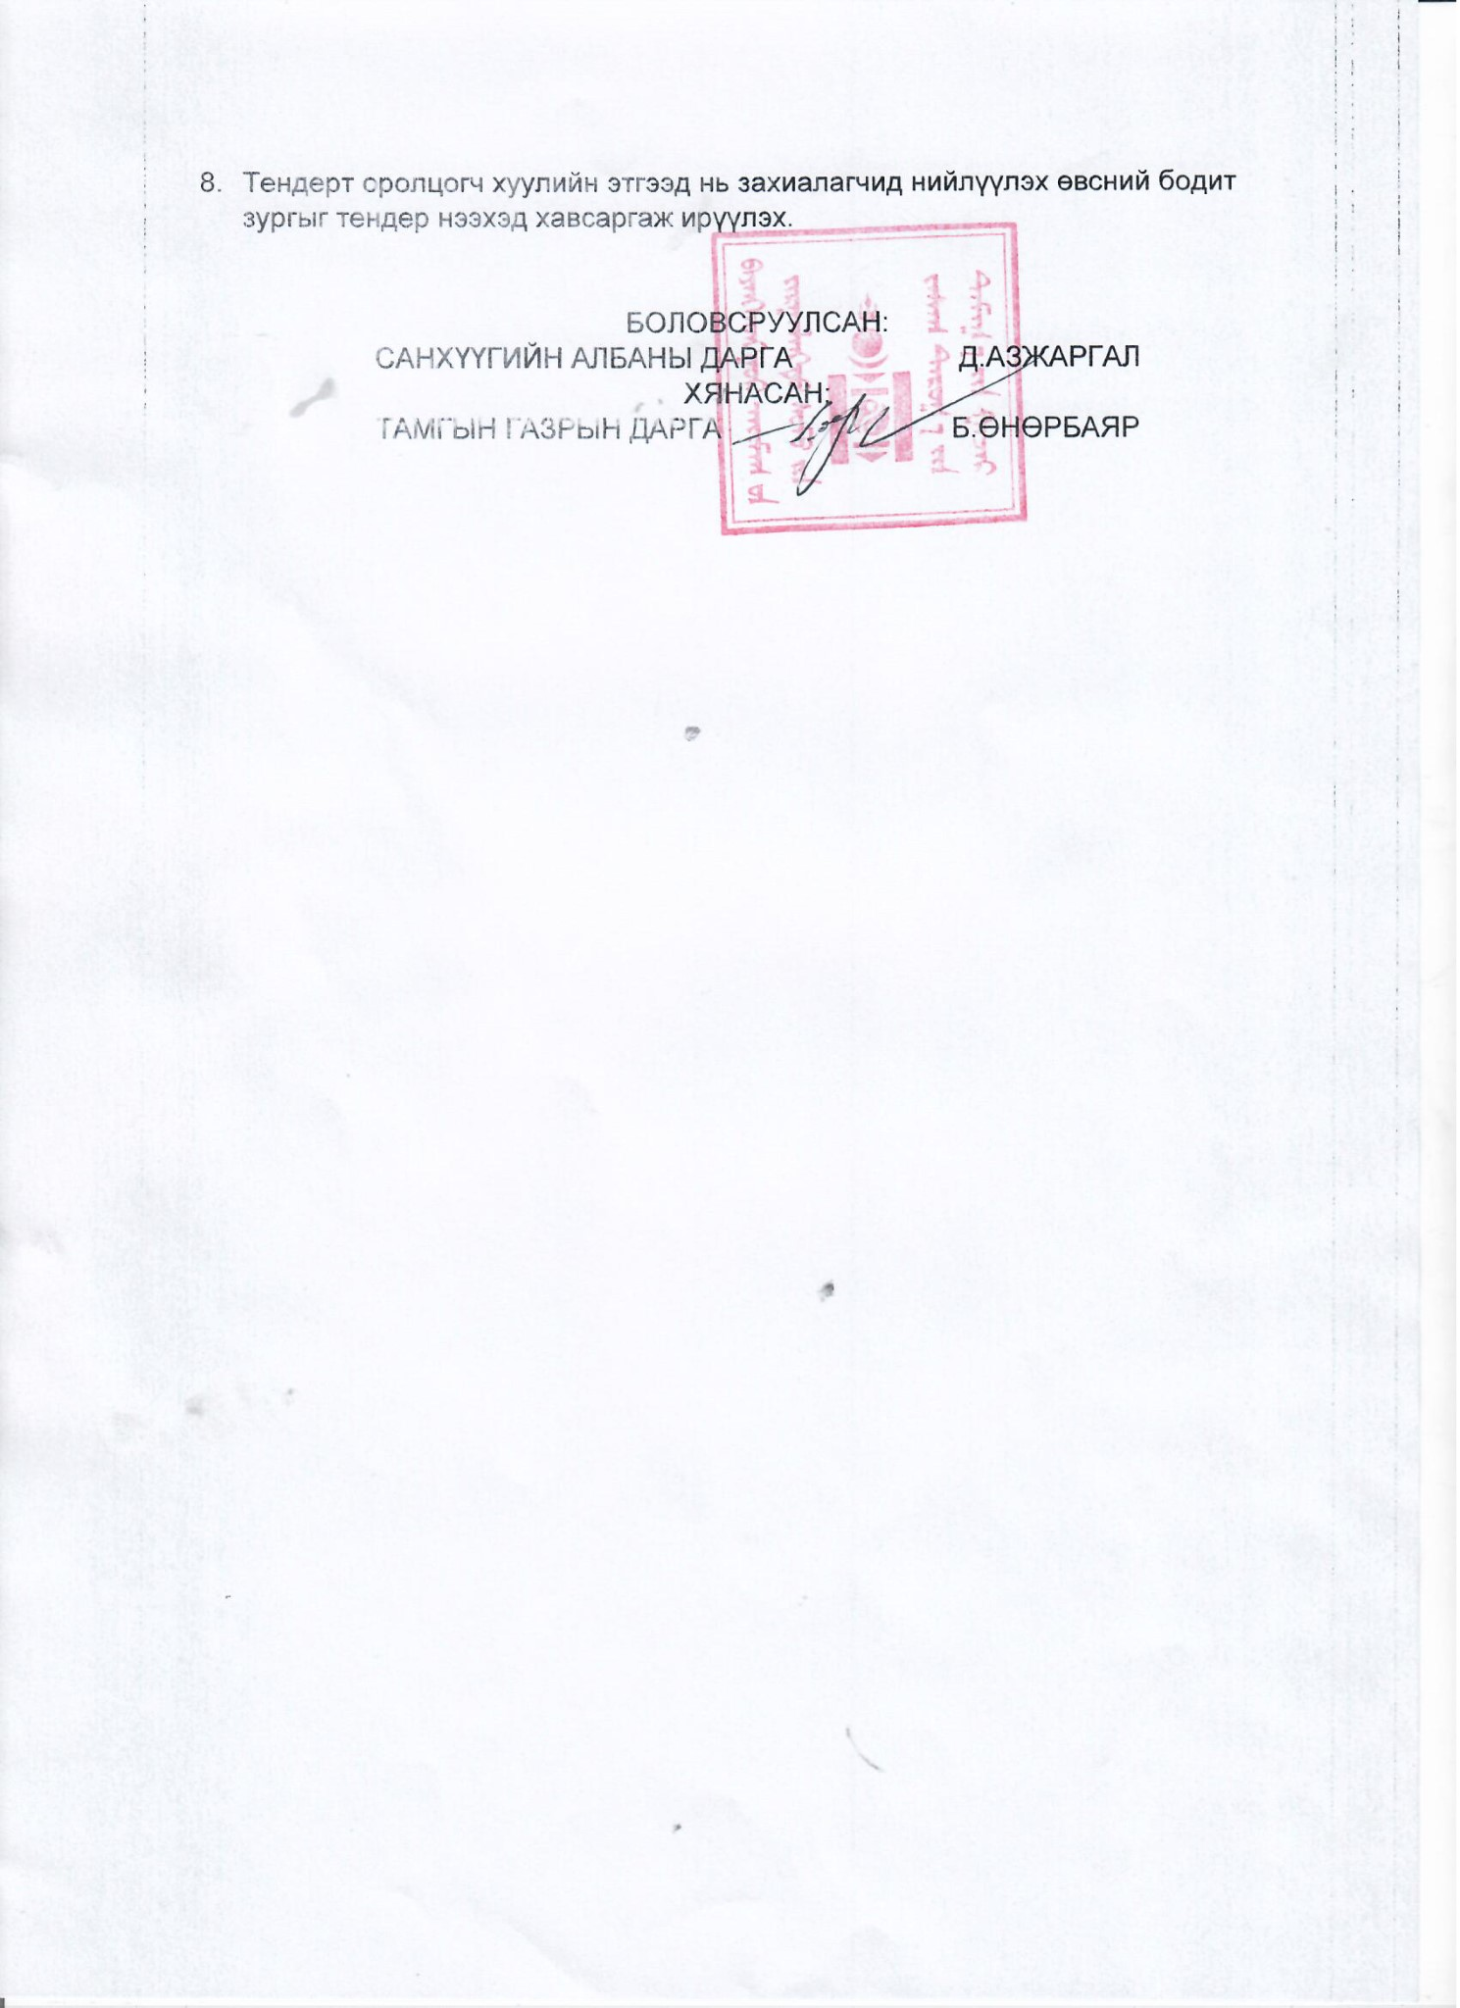

[**Click to BUY NOW**](https://www.tracker-software.com/product/pdf-xchange-editor)

[**!**](https://www.tracker-software.com/product/pdf-xchange-editor)

[**P**](https://www.tracker-software.com/product/pdf-xchange-editor)

[**D**](https://www.tracker-software.com/product/pdf-xchange-editor)

[**F**](https://www.tracker-software.com/product/pdf-xchange-editor)

[**-**](https://www.tracker-software.com/product/pdf-xchange-editor)

[**X**](https://www.tracker-software.com/product/pdf-xchange-editor)

[**C**](https://www.tracker-software.com/product/pdf-xchange-editor)

[**h**](https://www.tracker-software.com/product/pdf-xchange-editor)

[**a**](https://www.tracker-software.com/product/pdf-xchange-editor)

[**n**](https://www.tracker-software.com/product/pdf-xchange-editor)

[**g**](https://www.tracker-software.com/product/pdf-xchange-editor)

[**e**](https://www.tracker-software.com/product/pdf-xchange-editor)

[**E**](https://www.tracker-software.com/product/pdf-xchange-editor)

[**d**](https://www.tracker-software.com/product/pdf-xchange-editor)

[**i**](https://www.tracker-software.com/product/pdf-xchange-editor)

[**t**](https://www.tracker-software.com/product/pdf-xchange-editor)

[**o**](https://www.tracker-software.com/product/pdf-xchange-editor)

[**r**](https://www.tracker-software.com/product/pdf-xchange-editor)

[**w**](https://www.tracker-software.com/product/pdf-xchange-editor)

[**w**](https://www.tracker-software.com/product/pdf-xchange-editor)

[**w**](https://www.tracker-software.com/product/pdf-xchange-editor)

[**.**](https://www.tracker-software.com/product/pdf-xchange-editor)

[**t**](https://www.tracker-software.com/product/pdf-xchange-editor)

[**r**](https://www.tracker-software.com/product/pdf-xchange-editor)

[**a**](https://www.tracker-software.com/product/pdf-xchange-editor)

[**c**](https://www.tracker-software.com/product/pdf-xchange-editor)

[**k**](https://www.tracker-software.com/product/pdf-xchange-editor)

[**e**](https://www.tracker-software.com/product/pdf-xchange-editor)

[**r**](https://www.tracker-software.com/product/pdf-xchange-editor)

[**-**](https://www.tracker-software.com/product/pdf-xchange-editor)

[**s**](https://www.tracker-software.com/product/pdf-xchange-editor)

[**o**](https://www.tracker-software.com/product/pdf-xchange-editor)

[**f**](https://www.tracker-software.com/product/pdf-xchange-editor)

[**t**](https://www.tracker-software.com/product/pdf-xchange-editor)

[**w**](https://www.tracker-software.com/product/pdf-xchange-editor)

[**a**](https://www.tracker-software.com/product/pdf-xchange-editor)

[**r**](https://www.tracker-software.com/product/pdf-xchange-editor)

[**e**](https://www.tracker-software.com/product/pdf-xchange-editor)

[**.**](https://www.tracker-software.com/product/pdf-xchange-editor)

[**c**](https://www.tracker-software.com/product/pdf-xchange-editor)

[**o**](https://www.tracker-software.com/product/pdf-xchange-editor)

[**m**](https://www.tracker-software.com/product/pdf-xchange-editor)

[**Click to BUY NOW**](https://www.tracker-software.com/product/pdf-xchange-editor)

[**!**](https://www.tracker-software.com/product/pdf-xchange-editor)

[**P**](https://www.tracker-software.com/product/pdf-xchange-editor)

[**D**](https://www.tracker-software.com/product/pdf-xchange-editor)

[**F**](https://www.tracker-software.com/product/pdf-xchange-editor)

[**-**](https://www.tracker-software.com/product/pdf-xchange-editor)

[**X**](https://www.tracker-software.com/product/pdf-xchange-editor)

[**C**](https://www.tracker-software.com/product/pdf-xchange-editor)

[**h**](https://www.tracker-software.com/product/pdf-xchange-editor)

[**a**](https://www.tracker-software.com/product/pdf-xchange-editor)

[**n**](https://www.tracker-software.com/product/pdf-xchange-editor)

[**g**](https://www.tracker-software.com/product/pdf-xchange-editor)

[**e**](https://www.tracker-software.com/product/pdf-xchange-editor)

[**E**](https://www.tracker-software.com/product/pdf-xchange-editor)

[**d**](https://www.tracker-software.com/product/pdf-xchange-editor)

[**i**](https://www.tracker-software.com/product/pdf-xchange-editor)

[**t**](https://www.tracker-software.com/product/pdf-xchange-editor)

[**o**](https://www.tracker-software.com/product/pdf-xchange-editor)

[**r**](https://www.tracker-software.com/product/pdf-xchange-editor)

[**w**](https://www.tracker-software.com/product/pdf-xchange-editor)

[**w**](https://www.tracker-software.com/product/pdf-xchange-editor)

[**w**](https://www.tracker-software.com/product/pdf-xchange-editor)

[**.**](https://www.tracker-software.com/product/pdf-xchange-editor)

[**t**](https://www.tracker-software.com/product/pdf-xchange-editor)

[**r**](https://www.tracker-software.com/product/pdf-xchange-editor)

[**a**](https://www.tracker-software.com/product/pdf-xchange-editor)

[**c**](https://www.tracker-software.com/product/pdf-xchange-editor)

[**k**](https://www.tracker-software.com/product/pdf-xchange-editor)

[**e**](https://www.tracker-software.com/product/pdf-xchange-editor)

[**r**](https://www.tracker-software.com/product/pdf-xchange-editor)

[**-**](https://www.tracker-software.com/product/pdf-xchange-editor)

[**s**](https://www.tracker-software.com/product/pdf-xchange-editor)

[**o**](https://www.tracker-software.com/product/pdf-xchange-editor)

[**f**](https://www.tracker-software.com/product/pdf-xchange-editor)

[**t**](https://www.tracker-software.com/product/pdf-xchange-editor)

[**w**](https://www.tracker-software.com/product/pdf-xchange-editor)

[**a**](https://www.tracker-software.com/product/pdf-xchange-editor)

[**r**](https://www.tracker-software.com/product/pdf-xchange-editor)

[**e**](https://www.tracker-software.com/product/pdf-xchange-editor)

[**.**](https://www.tracker-software.com/product/pdf-xchange-editor)

[**c**](https://www.tracker-software.com/product/pdf-xchange-editor)

[**o**](https://www.tracker-software.com/product/pdf-xchange-editor)

[**m**](https://www.tracker-software.com/product/pdf-xchange-editor)